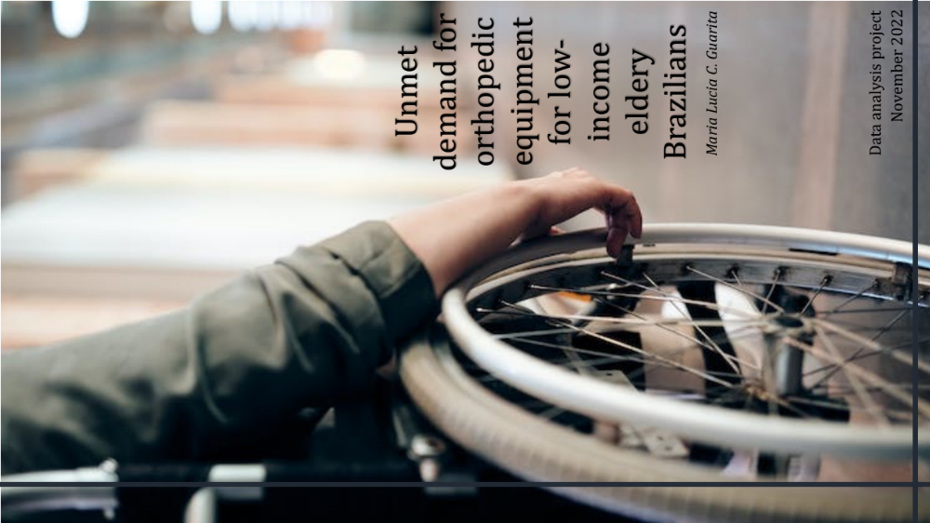

First section

PROJECT BRIEF

Unmet demand for orthopedic equipament for low-income eldery Brazilians
“Frihedsprodukter Company”

Goal

To assist the the stakeholders of a fictitious Danish company of orthopedic products (Frihedsprodukter) to assess whether Brazil would be an interesting country to implement a philanthropic project for the donation of orthopedic equipments.

Context

It is known the importance of orthopaedic equipment to a person with a disability regarding their displacement, independence, and consequent quality of life. Frihedsprodukter is a solid company with a consolidated market in Europe, especially focused on the elderly, whose main shareholder's dream would be to help developing countries when it reached a certain amount of production. Given that it still aims at a possible implementation of its headquarters in Brazil in the future, it believes that it is strategic to unite the desire for philanthropy to make the name of its brand known before the product is implemented in America, but for that it needs to know the market and the need for donations in Brazil. The company informs that the following orthopaedic equipment will be available for donation: wheelchair, walker, cane, crutches, seat lift, bed side support, adaptations for eating.

Stakeholders

- Frihedsprodukter Company President: “Another dream coming true, reinforcing our commitment as a company to respect diversity, encourage opportunity, and zeal for freedom for all.”

- Senior Vice President of Sales: “This is a great opportunity to get to know a little about the Latin American market and spread our brand”

- Vice President of Marketing: “We’re always looking into improving our targeting for ad campaigns.”

- Director of the Human Resources Department: “It is an incredible opportunity for us to be able to involve our employees in such a diverse activity, reinforcing our institutional values, human growth and respect for others.

Data Source:

- ELSI – Brasil 2nd Wave (2019-21)

Brazilian representative sample data of community-dwelling adults aged 50 years or older (Second wave collected from 2019-21)..

- Data Dictionary

Data Dictionary was constructed based on 2 questionaries (from ELSI-Brasil project.

- https://it.camelcamelcamel.com/product/B06ZZDYF6W?context=search&active=new

Other databases consulted for initial research:

- The Word Bank accessed November 10th, 2022
- IBGE – Instituto Brasileiro de Geografia e Estatística accessed November 10th, 2022

Why this Data Set?

- The sample encompasses the requested requirements for this activity.
- The sample that presents a wealth of collected data consistent with the demands of stakeholders
- The sample has serious and well-formulated documentation regarding the ethical and legal aspects of the collection.
- Well-described collection method.
- Apparent also rigorous collection method avoiding biases except for the sample purchasing power as all participants were from public institutions.

Second section

Data Set cleaned – sent by email.

Ethical issues:
The chosen database, ELSI-Brasil, was approved by the Ethics Committee of Fundação Oswaldo Cruz - Minas Gerais and the process is registered on Plataforma Brasil (CAAE: 34649814.3.0000.5091). Participants signed separate informed consent forms for each of the research procedures and authorized access to corresponding secondary databases. For use, permission was requested from the same on my behalf. For more information access – here.

Data Limitations found:

Sample size. There is no detailed description about other equipment, other than walking aids and wheelchair; there is no mention of the use of adaptations for eating. Lack of data on the value of equipment already purchased. Absence of other market data regarding the purchase of orthopedic equipment. As the data were collected in a public hospital, there may have been selection bias in terms of purchasing power.

Third section

Key Questions

The stakeholders would like to be able to answer the following key questions:

- Demographic and economic profile of the sample.
- Sample demand for the use of each orthopedic equipment and estimated number in Brazil.
- Sample demand for donation of each orthopedic equipment and estimated number in Brazil.
- Crossing economic data with equipment demands.
- Region of Brazil with the highest number of people in need.
- Brazilian region with the highest purchasing potential.

